Clacton Carnival Colouring Competition 2019
Launches here on:
Saturday 13th April from 10.30am.
Closing date: Saturday 22nd June 5pm

The Theme for the 2019 Clacton Carnival is
‘Best of British’

Age categories are Under 6, 6 – 9 and 9 - 12
All Sponsorship and prizes have been kindly donated by
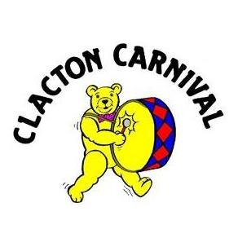
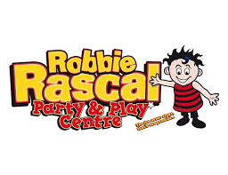
Robbie Rascals Play Centre

Clacton Carnival
Colouring Competition 2019
Conditions of Competition Entry

- Entrants must enter the age category relevant to their age on the closing date of the competition. Closing date is Sat 22nd June 2019.

- Each entrant must provide a contact number to receive notification of winning.

- Provided blank posters must be completed in a ‘theme’ related way to qualify.
2019 Theme is: ‘BEST OF BRITISH’

- Winners must use / redeem their prizes set by the Terms and Conditions of ‘Robbie Rascals Play Centre’. No cash alternative will be provided. And prizes are not transferrable.

- Entries must be received at ‘Robbie Rascals Play Centre OR at Clacton Library by Sat 22nd June 2019 to be considered

- Judges decision is final.

